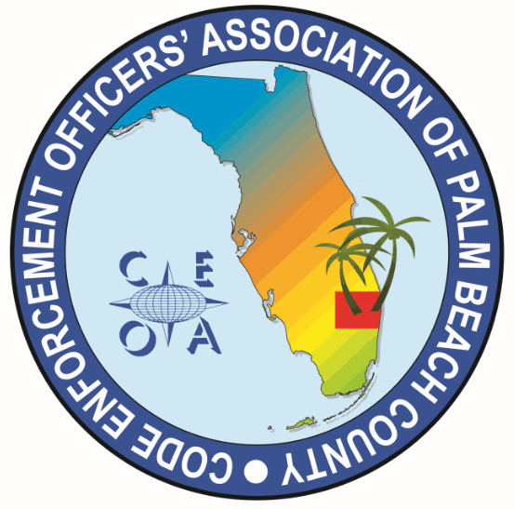

CODE ENFORCEMENT OFFICERS ASSOCIATION OF PALM BEACH COUNTY
BOARD MEETING AGENDA
MAY 8, 2026
11:00 AM
EATALIA
7784 OKEECHOBEE BLVD, WEST PALM BEACH 33411

CALL MEETING TO ORDER, ROLL CALL, ESTABLISH A QUORUM, RULES OF MEETING

APPROVAL OF THE FEBRUARY 18, 2026 MEETING MINUTES – MICHELLE MALKIN-DANIELS

TREASURER REPORT – JOE OLIVA

OLD BUSINESS

- ANNUAL BUDGET REVIEW AND APPROVAL OF 2026 - 2027 BUDGET – JOE OLIVA

NEW BUSINESS

- FILLING OF BOARD SEAT VACANCIES (UPDATE F.A.C.E. CHAPTER PAGE)

- F.A.C.E. CONFRENCE CHAPTER/RAFFLE TABLE RESPONSIBILITIES

- CONSIDERATION OF FUNDING DWAYNE JOHNSON CAMPAIGN MERCH

- FUTURE TRAINNG TOPICS, SPEAKERS AND DATES – SONJA BINNS

- ITEMS TO BE CONSIDERED AT NEXT MEETING

- SET NEXT MEETING DATE AND TIME

ADJOURNMENT

